  - join us for a
  - “Missing Maps”Mapathon! University of Cincinnati
November 3, 2018, 10 AM to 2 PM at 475 Langsam, Main Library
MAP - http://www.uc.edu/visitors.html

the Red Cross and the University of Cincinnati will hold a joint Mapathon and we invite you to join us! What is a Mapathon? It’s part of the Missing Maps project which engages people all over the world to map locations that are currently “missing” from maps, but where people live and many disasters occur. The work we do at the Mapathon will add to the knowledge of first responders as they plan and deliver humanitarian aid to people in these remote parts of the world. To participate, you do not need to be an experienced mapper, but you do need to do these steps
- RSVP for this event at…
https://goo.gl/forms/b2sAl9zlS4ajSklg1

- Visit www.MissingMaps.org to find out more information about what this movement is all about

- Register for an account at Openstreetmap.org to be able to participate in the mapping. Make sure you practice mapping before the Mapathon!
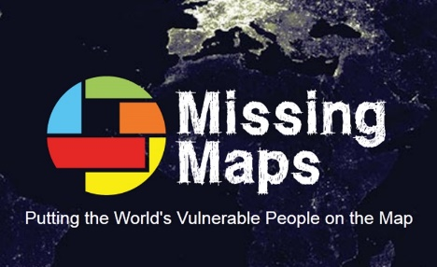
*Pizza and refreshments will be provided for a lunch break to refuel and continue mapping

